**SP-RM – Decomposition and Using Software**

Part I – Individual Quiz (Before Class)

Part II – Group Quiz (During Class)

1. When is one factor nested within another factor (2 pts)?

when each category of the first factor co-occurs with only one category of the other. In other words, an observation must be within one category of Factor 2 in order to have a specific category of Factor 1.

1. What is the estimated effect and degrees of freedom for the Within Factor of the Split Plot Design (2 pts)?

Grand = 1, Df = 1 Df = 8 Df Methods = 1, DF inter = 1, DF res = 8

**End of Part I**

1. Were you in class on time (2 pts)?

Yes

1. Do decomposition of the data and an ANOVA table for the factors in the Dog Diabetes data (6 pts).

On Excel sheet

1. Get an ANOVA table for the Dog Diabetes data and evaluate the results using software. Also, check the requirements of the residuals being normally distributed as well as the variances being equal (8 pts).

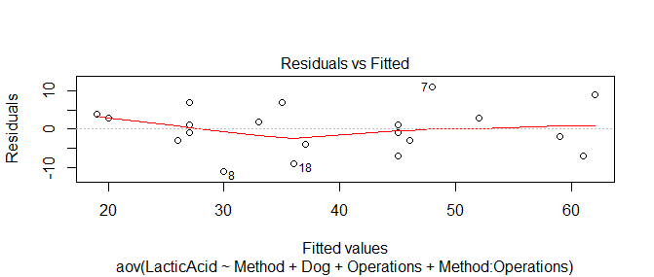

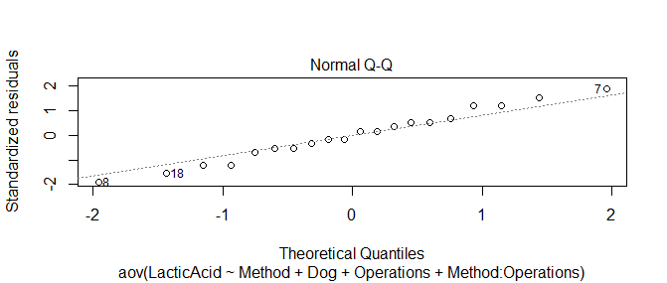

Error: Dog

Df Sum Sq Mean Sq F value Pr(>F)

Method 1 320 320.0 5.039 0.055 .

Residuals 8 508 63.5

---

Signif. codes: 0 ‘***’ 0.001 ‘**’ 0.01 ‘*’ 0.05 ‘.’ 0.1 ‘ ’ 1

Error: Within

Df Sum Sq Mean Sq F value Pr(>F)

Operations 1 2420 2420 28.471 0.000698 ***

Method:Operations 1 80 80 0.941 0.360388

Residuals 8 680 85

---

Signif. codes: 0 ‘***’ 0.001 ‘**’ 0.01 ‘*’ 0.05 ‘.’ 0.1 ‘ ’ 1